**Triggers:**

1. LG Washer

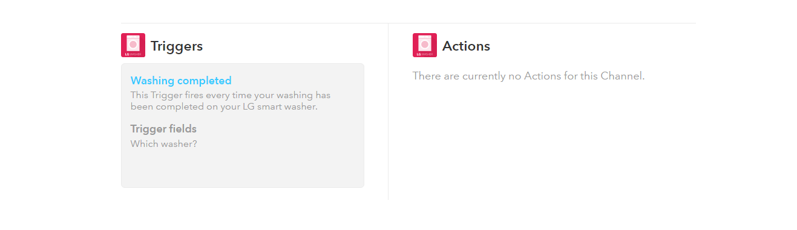

1. LG Dryer

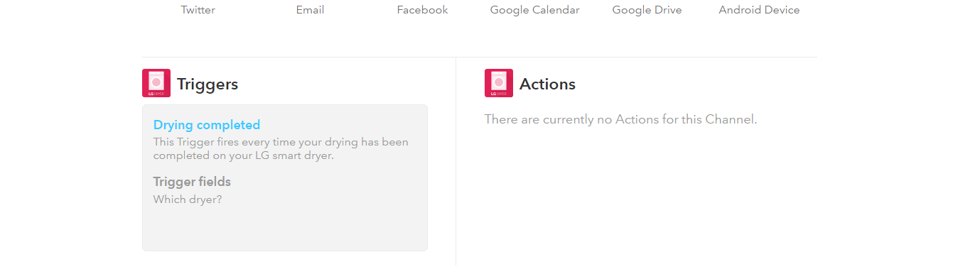

1. Weather



**Actions:**

1. **WeMo Humidifier**

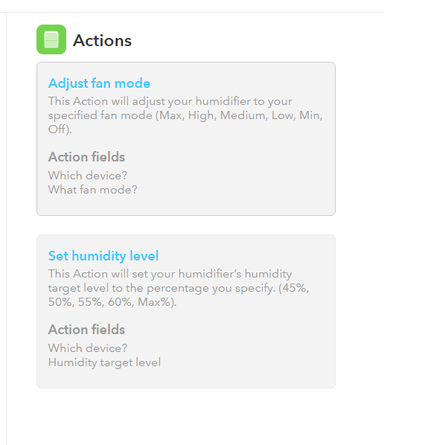

1. **SMS**

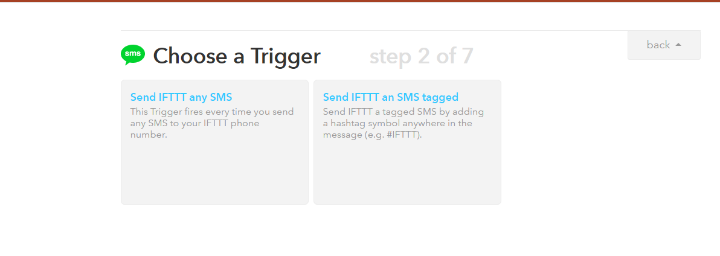

1. **Home Connect Oven**

